**Devanagari Text Recognition System**

**J COMPONENT PROJECT REPORT**

**FALL 2020**

Submitted by

**SHASHWAT NEGI (17BCE0322)**

**SAKSHI AGARWAL (17BCE0531)**

**KOMAL GULATI (17BCE0596)**

**SHASHWAT NEGI (17BCE0597)**

**MOTURU NIHARIKA (17BCE0951)**

**PRATIMA YADAV (17BCE2238)**

**ALKA (17BCE2287)**

*in partial fulfillment for the award* of the degree of

**B. Tech**

in

**Computer Science and Engineering**



Vellore-632014, Tamil Nadu, India

**School of Computer Science and Engineering**

October, 2020

**Contents**

**1. Title**

**2. Abstract-**

**3. Introduction**

3.1 Problem Statement

3.2 Motivation

3.3 Proposed Outcome

**4. Literature Survey**

**5. Requirement Gathering**

5.1 Function Requirements

5.2 Non-functional Requirements

**6. Project Scheduling**

6.1 Gantt Chart

6.2 Pert Chart

6.3 Timeline Chart

**7. System Design**

7.1 Use Case Diagram

7.2 Data Flow Diagram

7.3 Sequence and Collaboration Diagram

7.4 Activity Diagram

7.5 User Interface

**8. Proposed Methodology**

**9. Overview of Proposed Model**

**10. Implementation**

**11. References**

**Note: This is not the final project report**

1. **Title**

The title of our project is Devanagari Text Recognition System.

1. **Abstract**

Handwriting recognition has been one of the most fascinating and challenging research areas in the field of image processing and pattern recognition in the recent years. The aim of this project is to produce a system that will allow successful recognition of handwritten words, which is proven to be feasible even in noisy environments. This paper presents a method that performs pre-processing steps on hand written images such as skew and slant correction, baseline estimation, horizontal and vertical scaling. It uses structural features for feature extraction.

This project presents a segmentation-based and CNN based handwritten English and Hindi recognition systems. For the segmentation, a modified online segmentation method based on rules is applied. Then, convolutional neural networks are introduced for offline character recognition.

1. **Introduction**

**3.1 Problem Statement**

Despite the abundance of technological writing tools, many people still choose to take their notes traditionally: with pen and paper and sometimes also in their preferred regional language. However, there are drawbacks to handwriting text. It’s difficult to store and access physical documents in an efficient manner, search through them efficiently and to share them with others. A lot of the important information gets lost or does not get reviewed because of the fact that documents never get transferred.

Devanagari Text Recognition System is the process of automatic conversion of such handwritten documents into machine encoded text in three ways- English to English, from Hindi to Hindi and finally from Hindi to English. It has been a popular research area for many years due to various applications such as digitizing handwritten manuscripts, postal automation, matching documents, digitizing handwritten medical forms.

In this project, we take on the challenge of classifying the image of any handwritten word, which might be of the form of cursive or block writing. This project can be combined with algorithms that segment the word images in a given line image, which can in turn be combined with algorithms that classify the word in a given image of a whole handwritten page.

**3.2 Motivation**

Technical & Economical

In an area of character recognition so much research work can be traced for English. At present many HSR packages are available in a market commercially for recognizing printed text written in English, Chinese and Japanese, but there are hardly any systems that can convert the scripts written in Indian languages such as Hindi , Tamil ,Telugu , Bangla etc.

Our motivation behind the development of an accurate “Handwritten script recognition system” is:

1. Advancement of the automation process and can improve the interaction between man and machine in many Indian offices. (Technical)

2. Help individuals that use this system to exercise the convenience of a much more facilitated data entry method in their native language.

3. Relieving users from scanning and storing handwritten documents as images by identifying individual characters and converting them into any desired text format, making it easier to search for keywords or important lines and storing it. (Economical)

4. Providing a good alternative method of storing information as computer records which in turn save paper, human labour and time, it being an automated system.

**3.3 Project Outcome**

Major objective of the proposed project is to create a “Handwritten script recognition system” for recognizing English and Hindi handwritten characters and its patterns.

Many regional languages throughout the world have different writing styles which can be recognized with HSR systems using proper algorithms and strategies. The main aim of this project is to design an expert system for bilingual handwritten script that can effectively recognize a particular word of type format using the Artificial Neural Network approach. With the help of this product, users will be able to upload their documents and effectively be able to convert any handwritten document to a computer text encoded document. It will allow the user to convert a handwritten document in English or Hindi to a computer typed document in English or Hindi respectively and will also have the capability of converting a Hindi written document to an English typed document.

1. **Literature Survey**

***Research Paper 1 (Base Paper)***

**Title:**

Handwritten Bangla Character Recognition Using the State-of-the-Art Deep Convolutional Neural Networks

**Author:**

Md Zahangir Alom , Paheding Sidike , Mahmudul Hasan, Tarek M. Taha, and Vijayan K. Asari

**Date:**

August 2018

**Introduction:**

Automatic handwriting character recognition has many academic and commercial interests. (e main challenge in handwritten character recognition is to deal with the enormous variety of handwriting styles by different writers. Furthermore, some complex handwriting scripts comprise different styles for writing words .Handwritten character recognition is more challenging compared with the printed forms of character due to the following reasons:

(1) Handwritten characters written by different writers are not only no identical but also vary in different aspects such as size and shape;

(2) numerous variations in writing styles of individual character make the recognition task difficult;

(3) the similarities of different characters in shapes, the overlaps, and the interconnections of the neighbouring characters further complicate the character recognition problem. In summary, a large variety of writing styles and the complex features of the handwritten characters make it a challenge to accurately classifying handwritten characters. Bangla is one of the most spoken languages and ranked fifth in the world and spoken by more than 200 million people. In terms of Bangla character, it involves a Sanskrit-based script that is inherently different from English- or Latin-based scripts, and it is relatively difficult to achieve desired accuracy on the recognition tasks , therefore, developing a recognition system for Bangla characters is of great interest. Furthermore, Bangla also contains some special characters with equivalent representation of vowels. This makes it difficult to achieve a better performance with simple classification technique as well as hinders the development of a reliable handwritten Bangla character recognition (HBCR) system.

**Abstract:**

The contributions of this paper can be summarized as follows:

∙ First time to comprehensive evaluation of the state-of-the-art DCNN models including VGG Net , All Convolutional Neural Network (All-Conv) , Network in Network (NiN) , Residual Network (ResNet) , Fractal Network (FractalNet) , and Densely connected convolutional Network (DenseNet) on the application of HBCR.

∙ Extensive experiments on HBCR including handwritten digits, alphabets, and special character recognition.

∙ The better recognition accuracy is achieved, to the best of knowledge, compared with other existing approaches that are reported in the literature.

∙ Investigation of the performance of several popular deep convolutional neural networks (DCNNs) for handwritten Bangla character (e.g., digits, alphabets, and special characters) recognition.

∙ The experimental results indicated that DenseNet is the best performer in classifying Bangla digits, alphabets, and special characters.

∙ Specifically, we achieved a recognition rate of 99.13% for handwritten Bangla digits, 98.31% for handwritten Bangla alphabet, and 98.18% for special character recognition using DenseNet. To the best of knowledge, these are the best recognition results on the CMATERdb dataset.

∙ In future, some fusion-based DCNN models, such as Inception Recurrent Convolutional Neural Network (IRCNN) , will be explored and developed for handwritten Bangla character recognition.

***Research Paper 2 (2nd Base Paper)***

**Title:**

Handwriting Word Recognition Based on Neural Networks

**Author:**

Dr. Alia Karim Abdul Hassan, Mustafa S. Kadhm

**Date:**

October, 2015

**Introduction:**

Handwriting recognition is a very challenging field nowadays. In this paper a new architecture for handwriting word recognition system is proposed which is based on Neural Nets NN Classifier. The proposed work depends on :-

1) Handwriting word level

2) It does not need a character segmentation stage.

Arabic handwriting dataset AHDB has been used for training and testing the proposed system. The first step is preprocessing in handwriting recognition systems and it will help to reduce the variability of handwriting by correcting these factors and it will help to enhance the accuracy of segmentation and recognition methods. The features extraction is the second step in recognition systems which extract helpful information from the image text word to distinguish it from the other words. And the last step of the recognition is the classification that will make the decision to sign the text word to its desired class.

**Abstract:**

The contributions of the paper can be summarized as follows:

• The system uses 70% of the dataset for training and 30% for testing and obtained high accuracy with NN.

• The high accuracy achieved by several factors starting from the efficient preprocessing stage with the use of FCM with efficient feature extraction methods and finally with more accurate recognition classifier.

• This proposed system gave best recognition accuracy than the existing systems.

• This system achieved best recognition accuracy which is 95%.It is based on several feature extraction methods and NN classifiers.

***Research Paper 3***

**Title:**

Ote-Ocr Based Text Recognition and Extraction from Video Frames

**Author:**

Shashank Shetty , Arun S Devadiga, S.Sibi Chakkaravarthy, K.A.Varun Kumar

**Date:**

January,2014

**Introduction:**

Optical character recognition is playing a vital role in the field of image processing research and is used in various applications. OCR processes mainly with segmentation and classification. After the segmentations of the connected regions, the templates are compared with the segments. This is done to match the connected regions with the alphabets, numbers etc, to obtain the text. The text is got as the output from the O.C.R. The text got by comparison is written to the text file like notepad, wordpad etc. Hence the non-editable text, which was obtained from the text detection phase, is converted into the editable text by passing it to O.C.R. denotes the basics of OCR clearly.. OCR mainly deals with recognizing offline optical characters. Input sequence may be video or images which were scanned document or printed images. Major processing elements of OCR be denoted as Scanning , Pre- processing ,Segmentation ,Feature extraction ,Recognition. This method has better performance in recognizing the characters in the video frames.

**Abstract:**

∙ The goal of this paper is to provide a new method to detect and recognize the text from the video frames.

∙ The task performed is divided into a three step approach that combines the text detection and text recognition from the video frame. The video frame creation involves dividing the video into individual frames.

∙ The individual frame is grabbed and passed to the rest two phases. The text detection is a two-step approach, which involves text localization phase and the text verification phase.

∙ The text recognition involves the text verification phase and the optical character recognition phase.

∙ The final outcome of this paper is the detection of the text from the video frames in a word file. Experimental results demonstrating the proposed approach was also included, which shows the accuracy level of Optical character recognition (OCR) in terms of text extraction.

***Research Paper 4***

**Title:**

Machine translation using natural language processing

**Author:**

Middi Venkata Sai Rishita, Tanvir Ahmed Harris

**Date:**

January, 2019

**Introduction:**

Machine Translation is the translation of text or speech by a computer with no human involvement. It is a popular topic in research with different methods being created, like rule based, statistical and example based machine translation. Neural networks have made a leap forward to machine translation. This paper discusses the building of a deep neural network that functions as a part of the end-to-end translation pipeline. The completed pipeline would accept English text as input and return the French Translation. The project has three main parts which

are preprocessing, creation of models and Running the model on English Text. In this translation of text from one language to another, there is no human involvement and it is the machine which performs the process of conversion. There are three types of machine translation system-rules based, statistical and neural. Rule based is a conventional method which is a combination of language and grammar and the support of dictionaries. This work focuses on building an end to end machine translation pipeline. Several multiple existing architectures were discussed and finally a hybrid model was proposed to achieve a more powerful system for machine translation from English to French.

**Conclusions**

A deep neural network was built that functions as part of an end-to-end machine translation pipeline to convert English text as input and return the French translation. As compared to the other architectures discussed previously in terms of the validation loss the proposed network has performed far better. The accuracy was 96.71%. A random seed was fixed for reproducibility, a 3-fold cross validation test harness was determined and the model was compiled and evaluated.

***Research Paper 5***

**Title:**

A Modified Back propagation Algorithm for Optical Character Recognition

**Author:**

Jitendra Shrivastav, Prof. Ravindra Kumar Gupta, Dr. Shailendra Singh

**Date:**

June-2013

**Introduction:**

Character recognition is a process of distinguishing portioning and recognizing characters from pictures. Character recognition is a cycle of distinguishing and perceiving characters from input picture and changes over it into ASCII or other comparable mCharacter recognition is a specialty of recognizing portioning and distinguishing characters from picture. All the more correctly Character recognition is a cycle of distinguishing and perceiving characters from input picture and changes over it into ASCII or other identical machine editable structure machine editable structure . Optical character recognition includes interpretation of this content

picture into editable character codes, for example, ASCII. The number and kinds of preprocessing calculations utilized on the filtered picture depends upon various elements, for example, age of the archive, paper quality, goal of the examined picture, measure of slant in the picture, arrangement and design of the pictures and text of the content utilized and furthermore on the sort of characters: printed or manually written. In the wake of preprocessing, the recognition stage distinguishes singular characters, and changes over them into editable content.

**Abstract:**

In this paper, a survey of the number of strategies for optical character recognition takes place. we broke down the focal points and disadvantages of different OCR strategies. We then proposed an altered back propagation technique. It is utilized in the neural system. The proposed strategy processes mistake rate proficiently. It brings about expanding the exactness of the neural system. Every one of these calculations are depicted pretty much all alone. Handwritten character recognition is an exceptionally famous and computationally costly errand. We additionally clarify the basics of handwritten character recognition. We portray the present methodologies for manually written character recognition. From the wide assortment of productive procedures that have been created we will analyze the most significant ones. We will arrange the procedures and break down their exhibition dependent on both their run time execution and hypothetical contemplations. Their qualities and shortcomings are likewise explored. Incidentally, the conduct of the calculations is considerably more comparable as normal. Our proposed neural system based strategy is giving 100% exactness in OCR

***Research Paper 6***

**Title:**

Optical character recognition technique Algorithms

**Author:**

N. Venkata Rao, Dr. A.S.C.S.Sastry, A.S.N.Chakravarthy, Kalyanchkravarthi P

**Date:**

20th January 2016

**Introduction:**

Offline character recognition framework creates the record first, digitalizes, and puts it away in PC and afterward it is handled. Though, in the event of an online character recognition framework, character is prepared while it is under creation. Outside elements like pressure, speed of writing have any influence in case of offline systems but they have great impact on online systems. Once more, offline or online frameworks can be applied on optical character or handwritten characters. In view of that, frameworks can be delegated to OCR or HCR separately. Online strategies are bosses to their counterparts for example offline strategies because of the fleeting data present in the character age

Picture preparation and design recognition assumes a huge job in handwritten character recognition. There are different sorts of grouping of highlight extraction strategies like factual element based strategies, basic element based strategies and worldwide change procedures. Factual strategies depend on the arranging of how the information ought to be chosen.

Highlights removed can be either low level or elevated level. Low level highlights incorporate width, stature, waviness and viewpoint proportion and so on, of the character. These by themselves can't be utilized to recognize one character from another in the character set of the

dialects. Along these lines, there are the quantity of other elevated level highlights which incorporates number and position of circles, straight lines, features and bends and so forth

**Abstract:**

In this paper, we present another neural system (NN) based technique for optical character recognition (OCR) just as handwritten character recognition (HCR). Trial results show that our proposed methodologies expanded precision in optical character recognition just as handwritten character recognition. We present through a diagram of existing handwritten character recognition strategies. Transformation of handwritten characters is significant for making a few significant reports identified with our history, for example, compositions into machine editable structure, so that, it tends to be effortlessly gotten to and pres free work is going on in Optical Character Recognition that is the handling of printed/PC produced archive, handwritten and physically made record preparing for example handwritten character recognition.

1. **Functional Requirements**

**5.1 Functional Requirements**

We have classified the Functional Requirements as follows:

**5.1.1 Building a Data set**

First of all we need to gather a huge database which should consist of several images of alphabets and words. This will be separately collected for both Hindi and English. Further we will need to clean the data set to remove any non-relevant or unreliable data from the data set. This would reduce the training and testing time, and would increase the accuracy of the final result.

**5.1.2 Taking/choosing the desired text image**

The system takes a document from the user as an input. This document contains hand written text in either English or Hindi. The system identifies the area containing the handwritten text. The user must upload a clear image so that the system will be able to easily identify the text. If the input is blurry or pixelated, the system won’t be able to read the characters and hence won’t be able to translate the text.

**5.1.3 Recognition of the text**

Once the user gives the system a scanned document, the system performs feature detection for computing image information and making local decisions at every image point whether there is an image feature of a given type at that point or not. The resulting features will be subsets of the

image domain, often in the form of isolated points, continuous curves or connected regions. Based on the feature the system identifies the alphabet by using the trained data set. This way alphabet by alphabet the entire text is converted from handwritten script to digital text.

**5.1.4 Translating the text**

Once the handwritten input provided by the user has been converted into digital text, we can easily convert it into the language requested by the user. This can be done by using another trained and tested data model. This is then converted into a document and displayed as output to the user.

**5.1.5 Feedback**

The system should allow the user to provide feedback on their experience and report any bugs or glitches that might have happened during the functioning .

**5.2 Non - Functional Requirements**

After the functional requirements, we have been able to classify the non-functional requirements as follows :

**5.2.1 Usability Requirements**

The application shall be user friendly and shouldn't require any guidance to be used. In other words, the application has to be as simple as possible, so the users might use it easily.We plan to keep the interface quite simple and straightforward so that anyone can understand it. The user should only click on upload a file button and then directly click on the button to extract the document with output text without any complications.

**5.2.2 Reliability Requirements**

The application should not have any unexpected failure. In order to avoid any failure's occurrence, the specifications have been respected and followed correctly. The only problem that may occur in some cases is that the application might not get perfect accuracy of the characters in the picture, and the grammar might be a little bit off.

**5.2.3 Efficiency Requirements**

**5.2.3.1 Performance**

The application response time shall be adequate and sufficient enough, that's why the time required for this application to respond to its user's actions has to be managed and controlled. But in order to maintain the performance of the application, the user has to follow the required steps to get the desired result.

This can be achieved by using a pre-trained data set or by using a heavy duty GPU to train the data set as it would significantly reduce the training and testing time.

**5.2.3.2 Portability Requirements**

The application should support different Operating Systems.

1. **Project Scheduling**  (Note: Slack included in schedule)

|  |  |  |
| --- | --- | --- |
| Task 1 | Data Acquisition | 4 Days |
| Task 2 | Developing module 1- English to English followed by testing and training | 10 Days |
| Task 3 | Developing module 2- Hindi to Hindi followed by testing and training | 14 Days |
| Task 4 | Developing module 3- Hindi to English followed by testing and training | 22 Days |
| Task 5 | Frontend development | 16 Days |
| Task 6 | Implementing any changes as per feedback after Assessment 4 | 4 Days |
| Task 7 | Integration | 1 Day |
| Task 8 | Testing | 7 Days |
| Task 9 | Debugging | 9 Days |
| Duration of Project | Handwritten Script Recognition System | ~70 Days |

**6.1 Gantt Chart**

# **C:\Users\Shashwat\Downloads\WhatsApp Image 2020-09-01 at 09.58.35.jpeg**

# **C:\Users\Shashwat\Downloads\WhatsApp Image 2020-08-28 at 19.43.29.jpeg**

**6.2 Timeline Chart**

# **C:\Users\Shashwat\Downloads\WhatsApp Image 2020-08-28 at 19.43.30.jpeg**

**6.3 Pert Chart**  (Note : Zoom in to view)

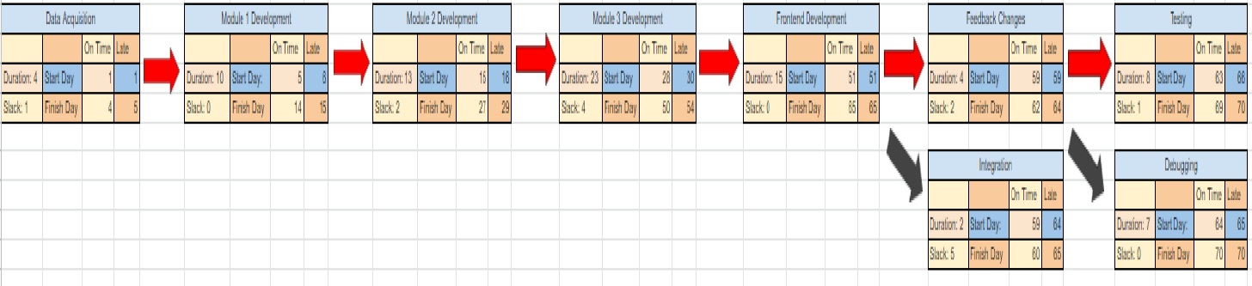

1. **System Design**

**7.1 Use Case Diagram**

**Stakeholder**

* Application /System Developer- The developer who created the system modules and is responsible for integration of all modules and smooth functioning.
* Administrator – Oversees the Smooth functioning for system and sees feedback.
* Government Employee – Uses the system to convert documents in Hindi to English and vice versa.
* User – Uses the system to convert the English and Hindi documents to its digital text format.

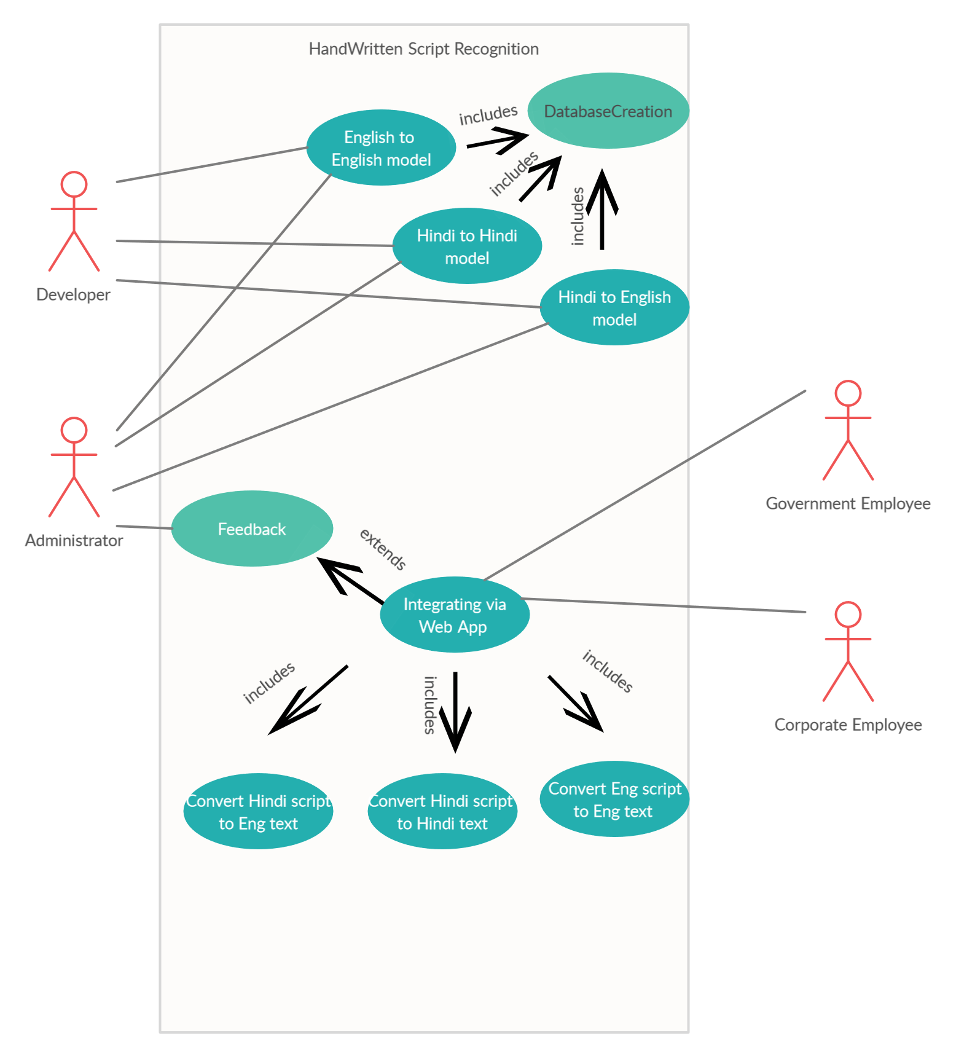

**7.2** **Data Flow Diagram**

Data Flow Diagram (DFD) is a graphical representation of data flow in the Handwritten Script Recognition System .

**Level 0**

Context Diagram . L-0 represents the system a single process with its relationship with external entities

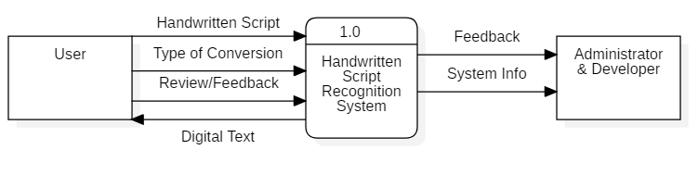

**Level 1**

L1 highlights the main functions of the system and data flow between its modules.

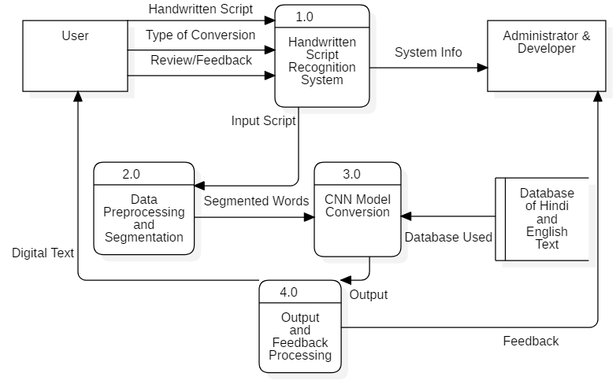

**Level 2**

Data Processing and Segmentation Modules Data flow

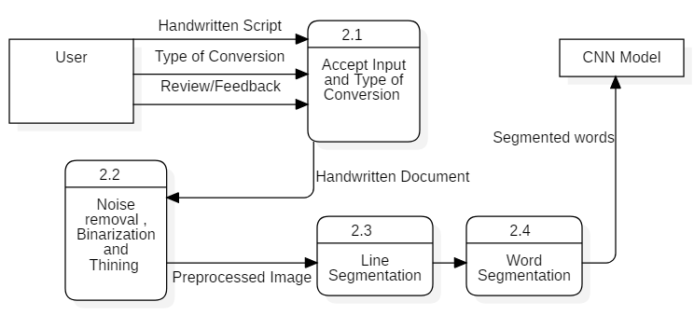

Model Training , Testing and Applying

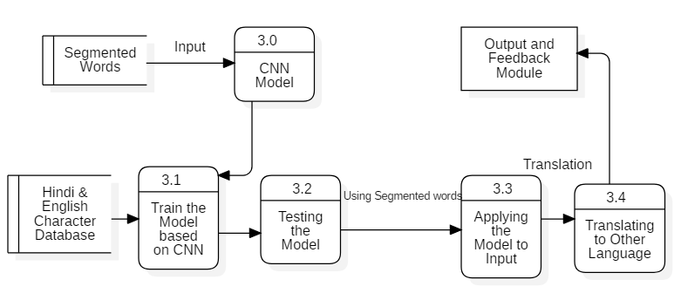

Output and Feedback Module Data flow

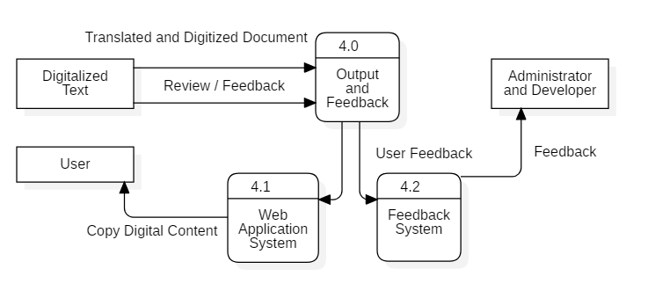

**7.3 Sequence and Collaboration Diagram**

Following are the sequence and collaboration diagrams for Handwritten Script Recognition System which depict the interaction between the user and the system to perform a certain task.

These diagrams detail how the operations are carried out in sequence between the objects. The objects in these diagrams are the user, the Handwritten Script Recognition System and the converted document.

Sequence and collaboration diagram for

1. **Overall system:**

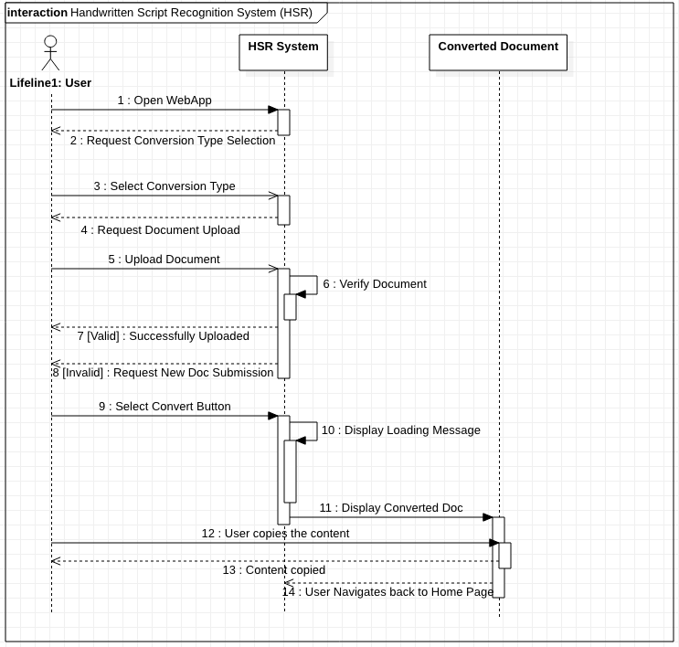

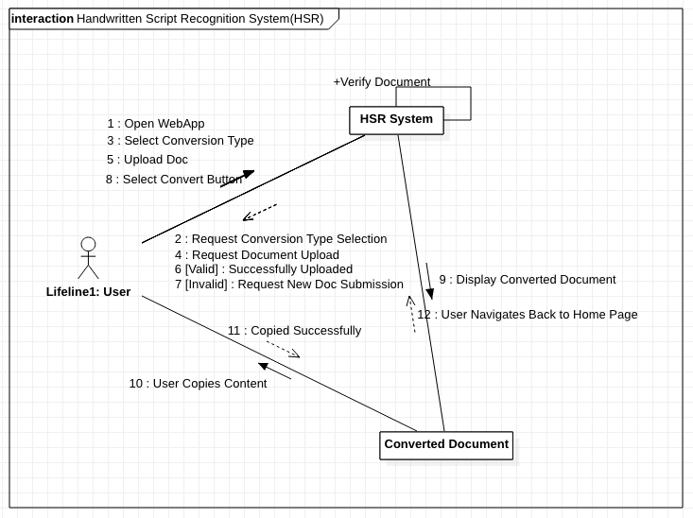

1. **Module 1**

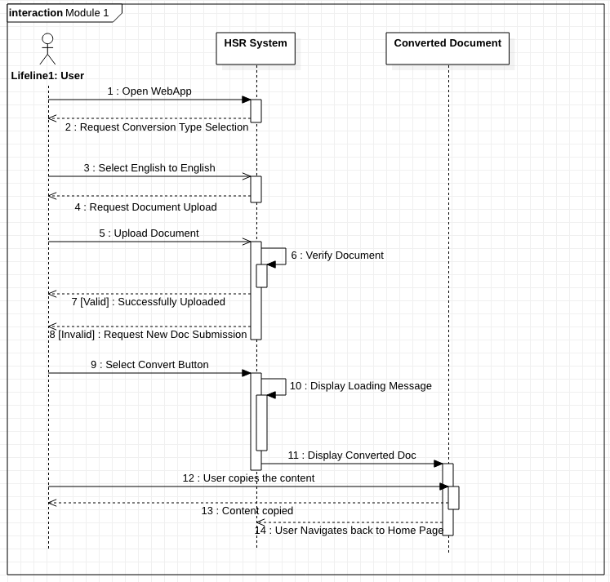

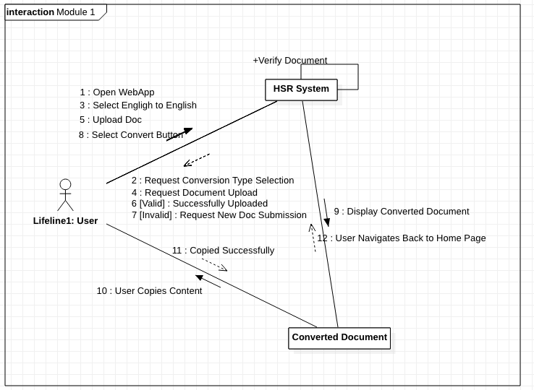

1. **Module 2**

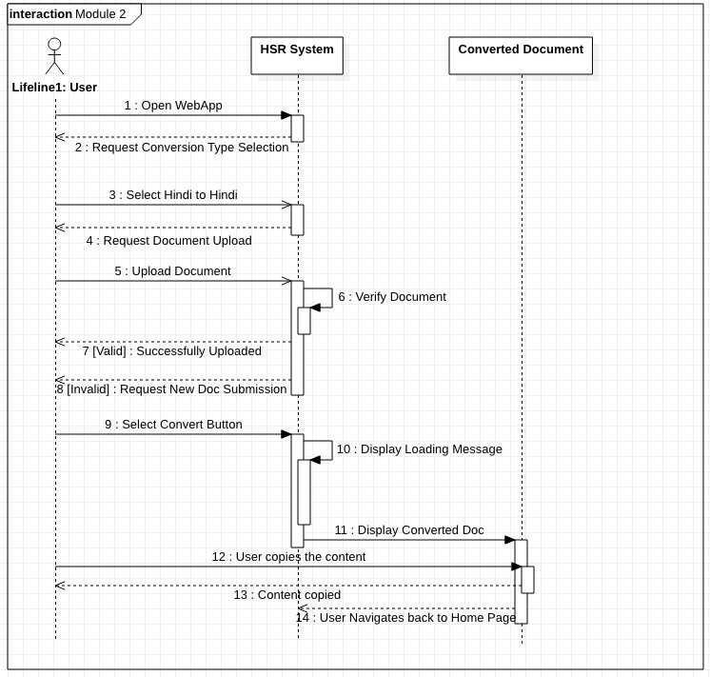

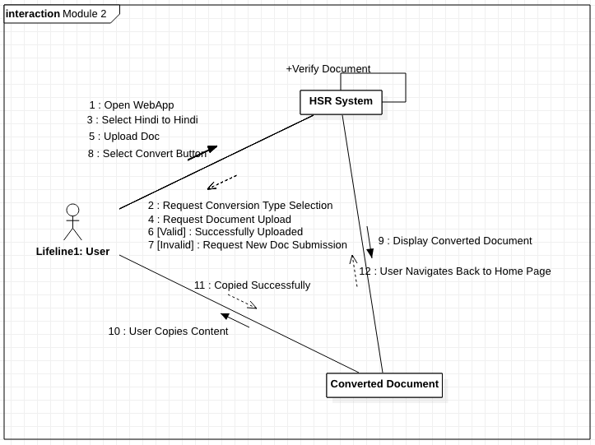

1. **Module 3**

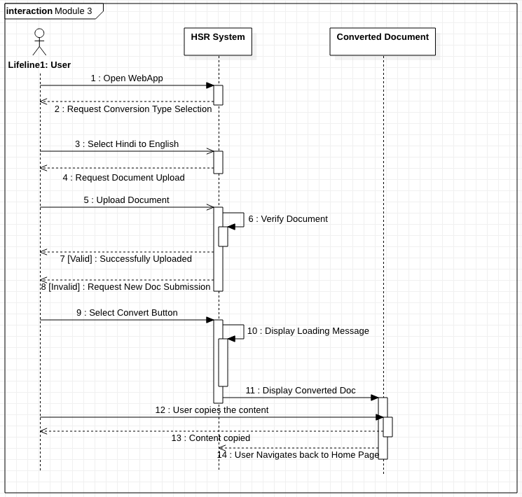

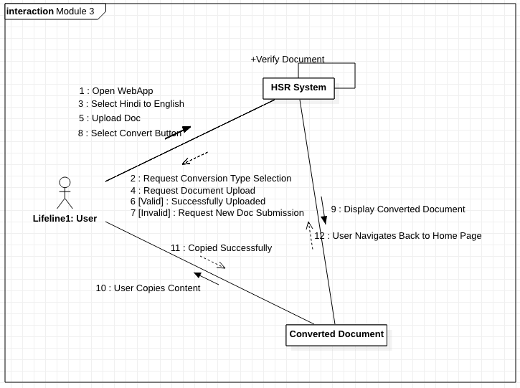

**7.4 Activity Diagram** (Note : Required Changes made in Activity Diagram)

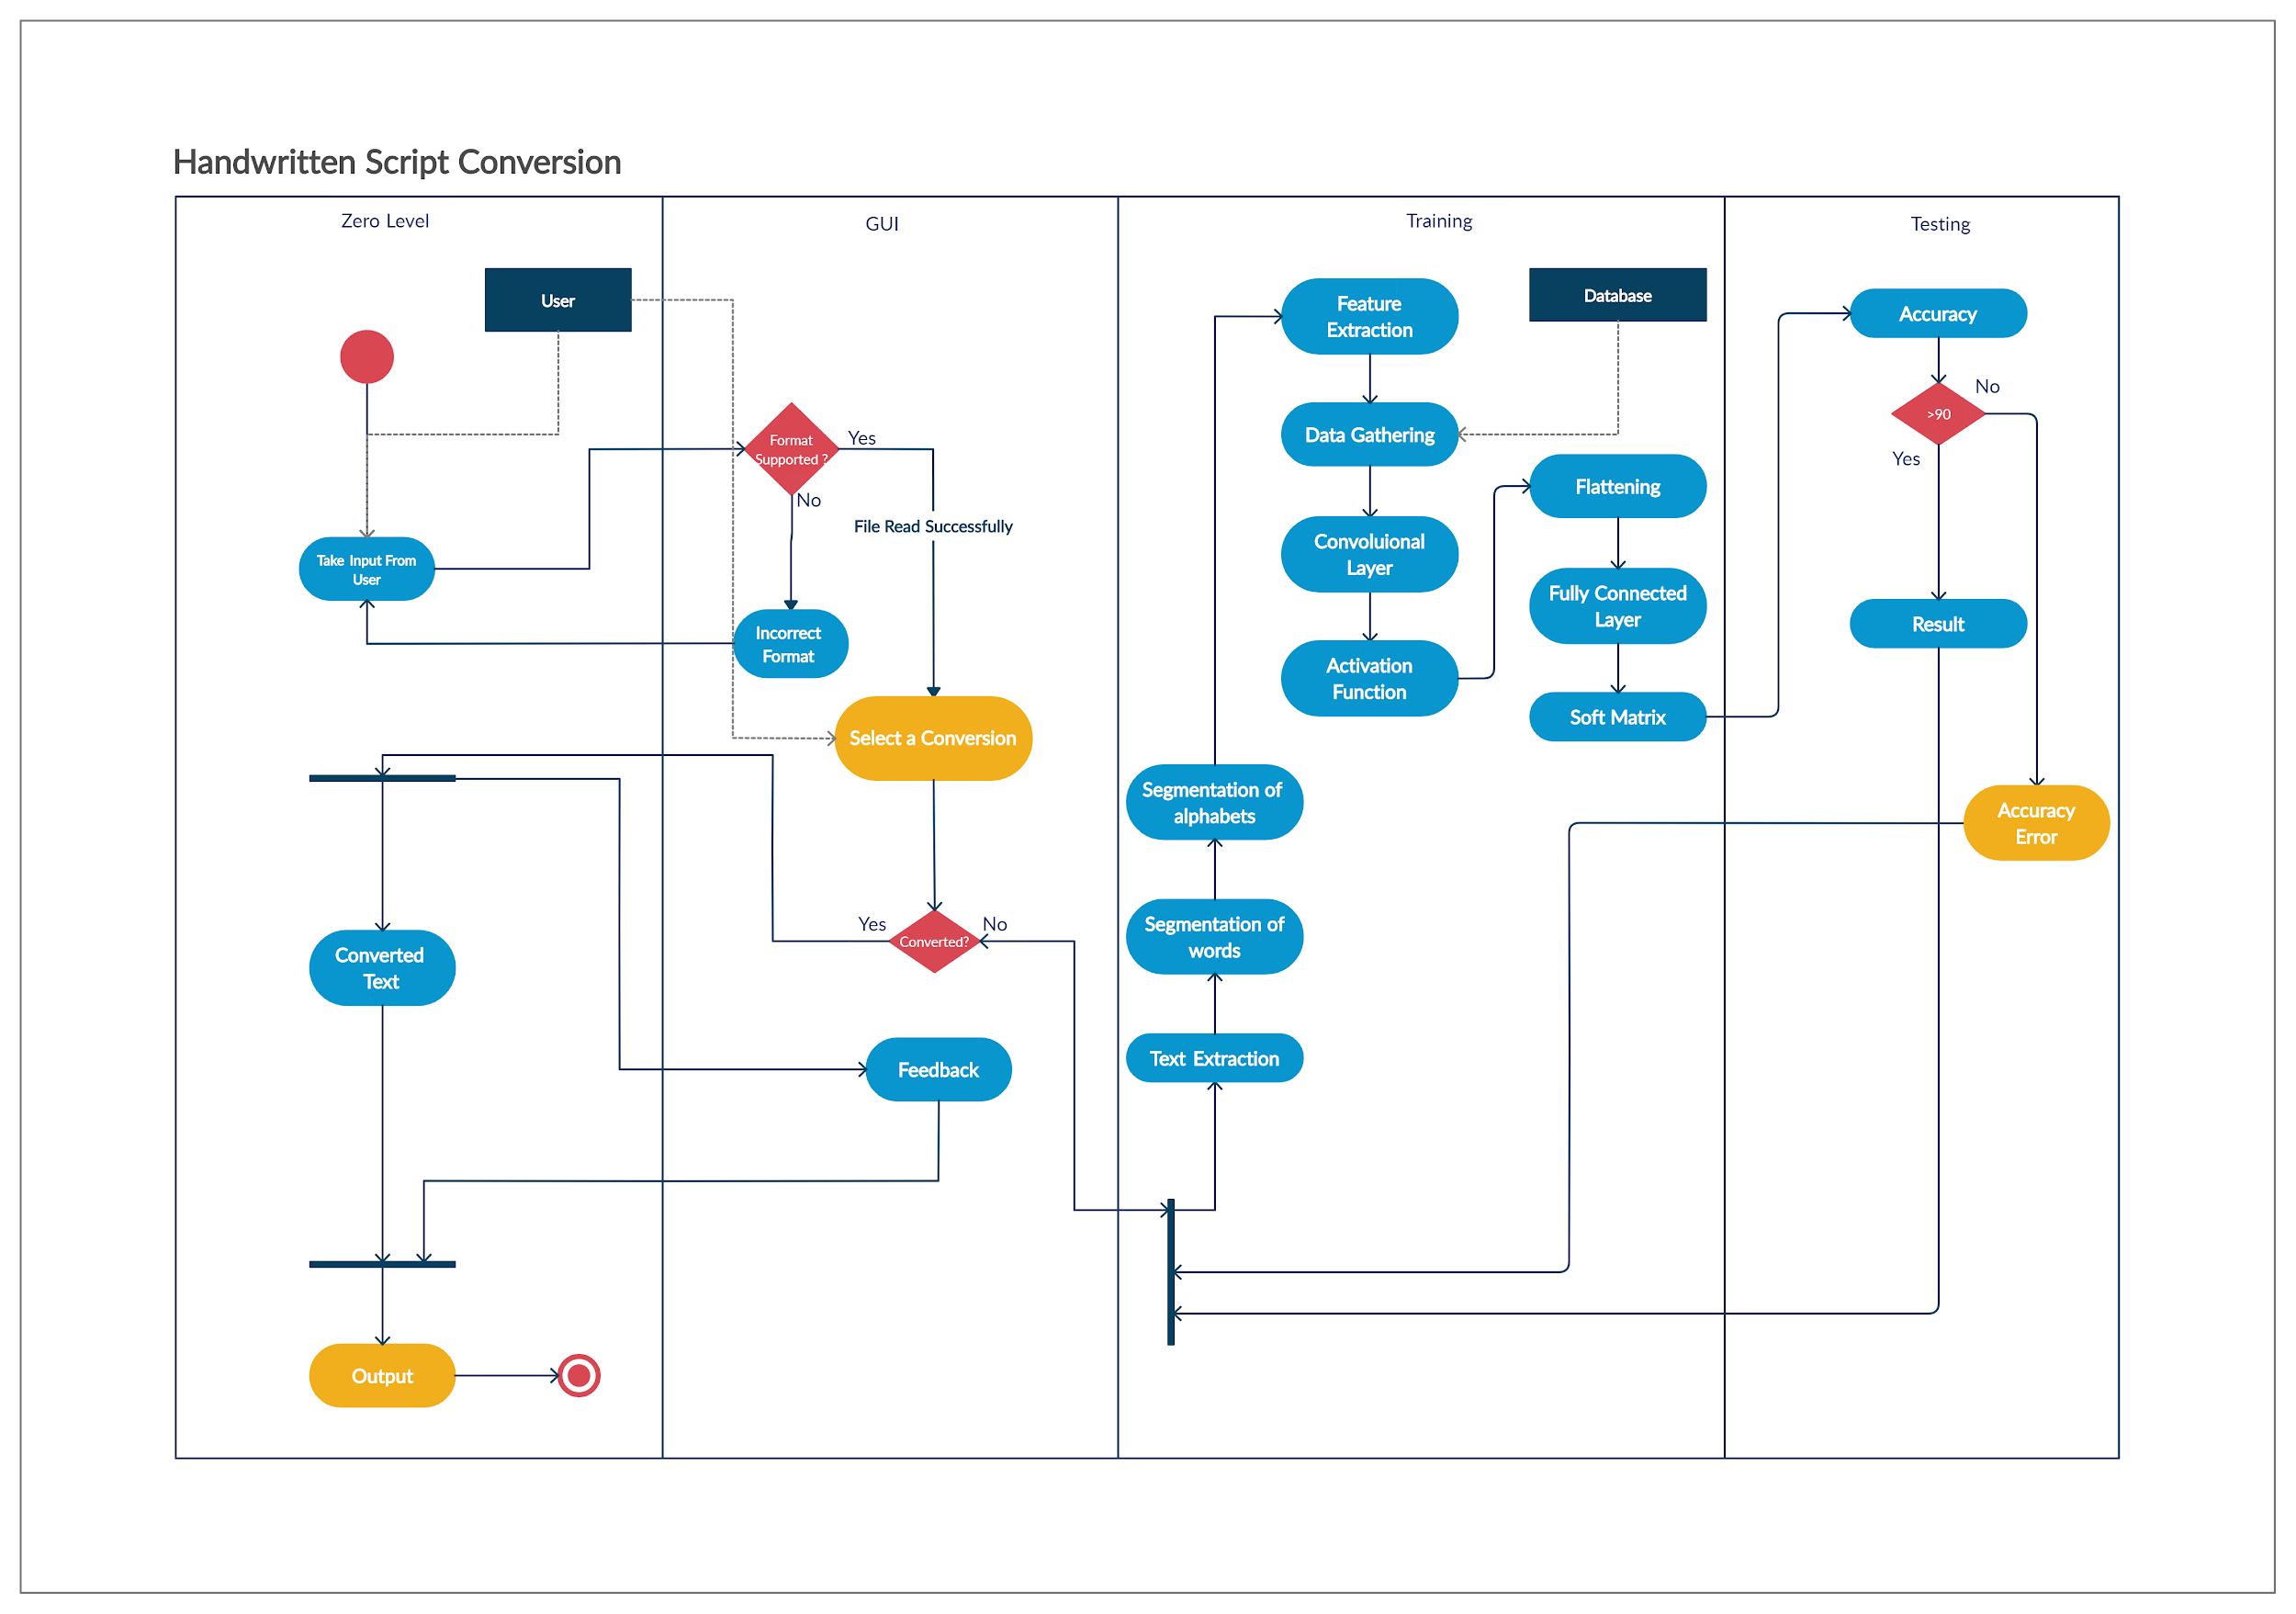

**7.5 User Interface**

1. **Home Page**

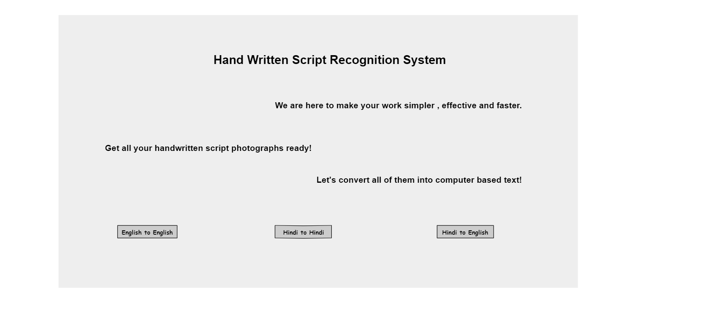

1. **English to English Translation page**

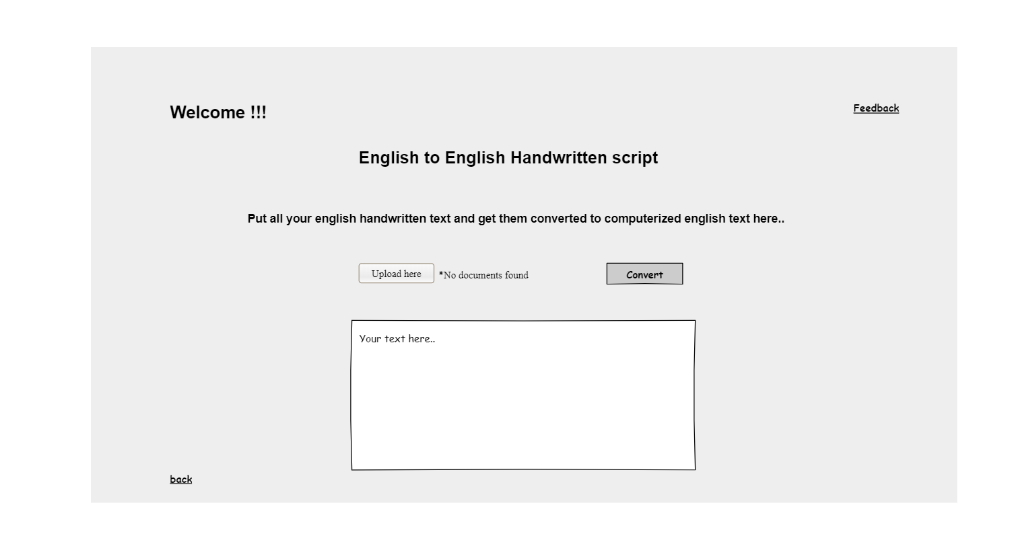

1. **Hindi to Hindi Translation page**

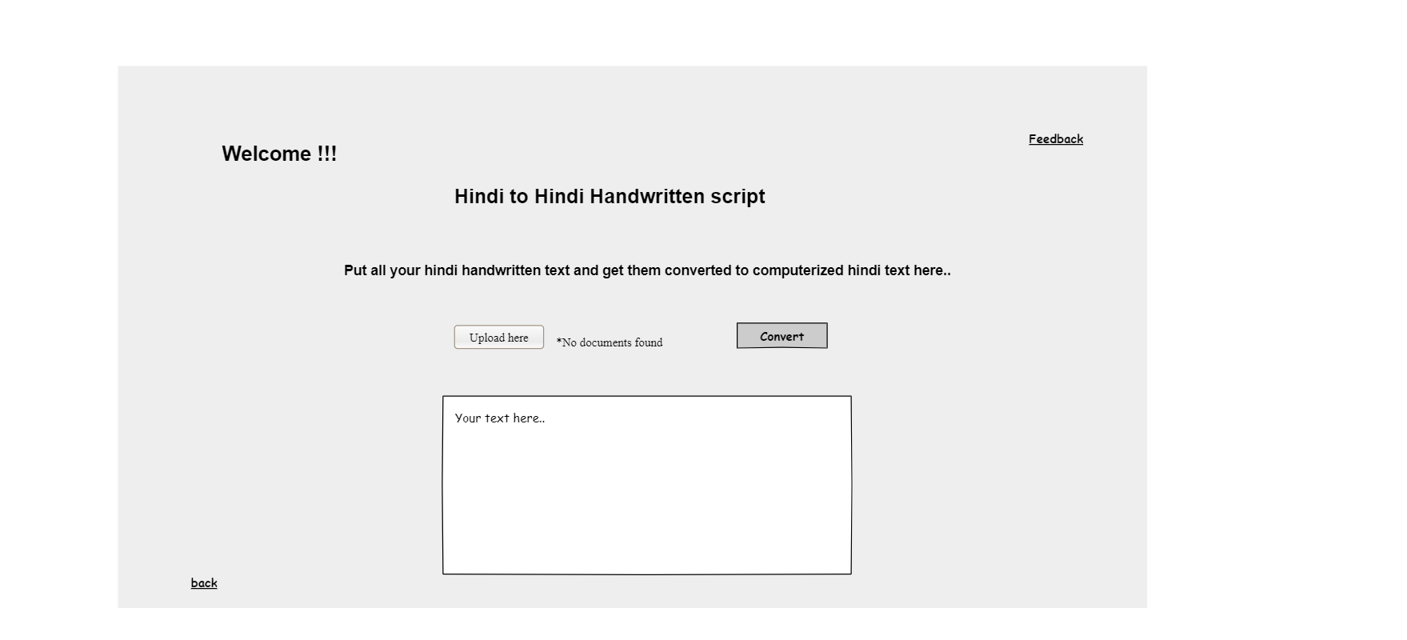

1. **Hindi to English Translation page**

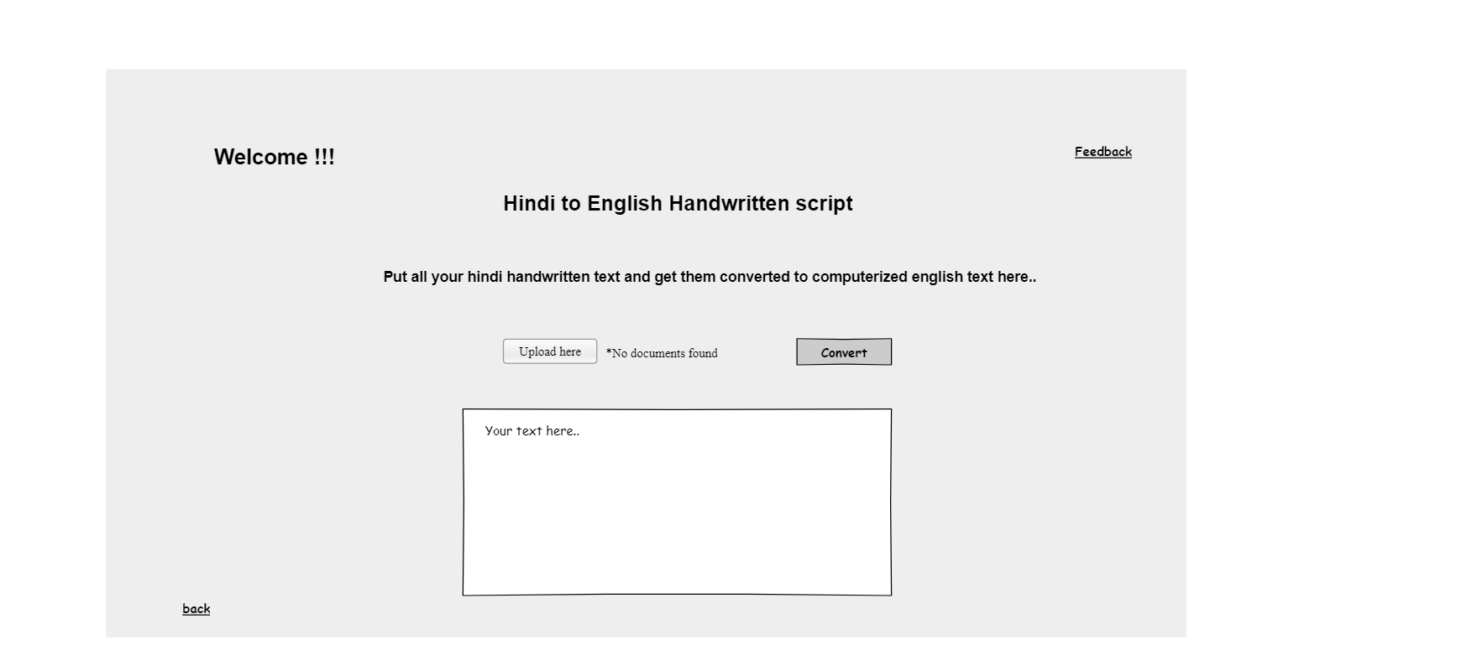

1. **Feedback page**

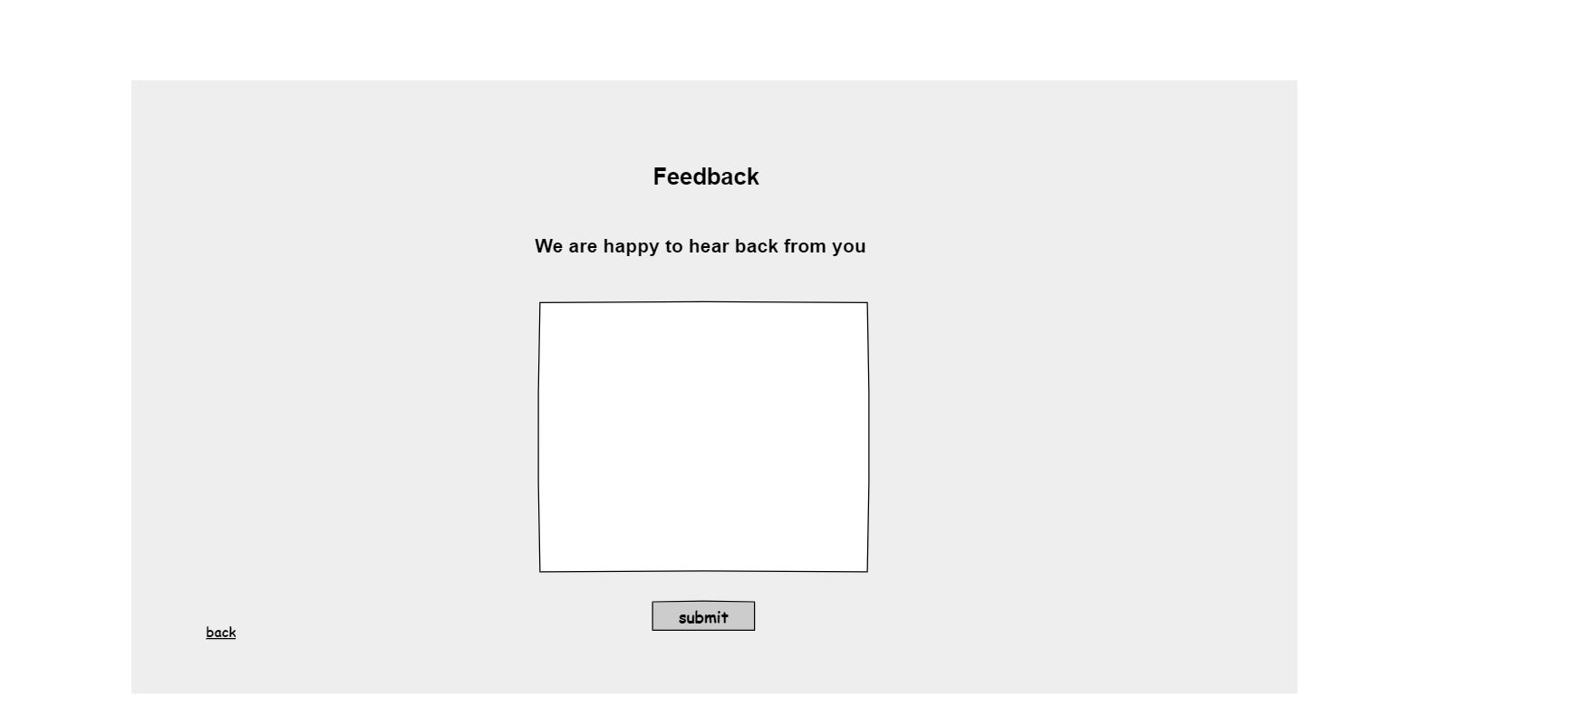

**8. Proposed Methodology**

Computational models of neural networks have been around for a long time, the first model proposed was by McCulloch and Pitts. Neural networks are made up of a number of layers with each layer connected to the other layers forming the network. A feed-forward neural network or FFNN can be thought of in terms of neural activation and the strength of the connections between each pair of neurons . In FFNN, the neurons are connected in a directed way having clear start and stop place i.e., the input layer and the output layer. The layer between these two layers, are called the hidden layers. Learning occurs through adjustment of weights and the aim is to try and minimize error between the output obtained from the output layer and the input that goes into the input layer. The weights are adjusted by a process of back propagation (in which the partial derivative of the error with respect to the last layer of weights is calculated). The process of weight adjustment is repeated in a recursive manner until the weight layer connected to the input layer is updated.

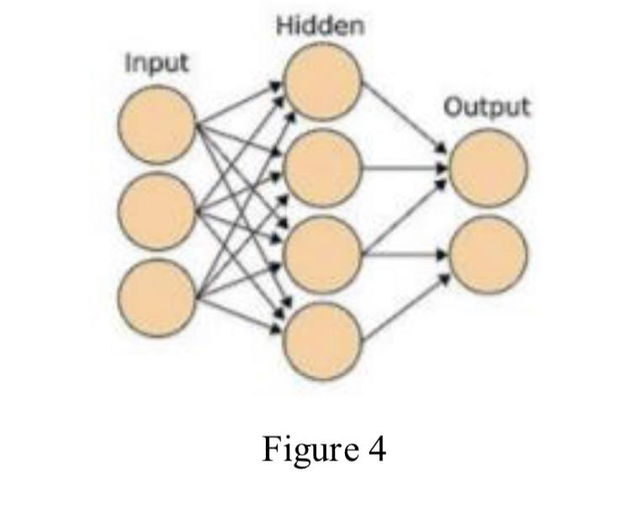

**Working of CNN algorithm:**

The input to the network is a 2D image. The network has an input layer which takes the image as the input, output layer from where we get the trained output and the intermediate layers called as the hidden layers. As stated earlier, the network has a series of convolutional and sub-sampling layers. Together the layers produce an approximation of input image data. CNNs exploit spatially local correlation by enforcing a local connectivity pattern between neurons of adjacent layers. Neurons in layer say, ‘m’ are connected to a local subset of neurons from the previous layer of (m-1), where the neurons of the (m-1) layer have contiguous receptive fields.

In the CNN algorithm, each sparse filter is replicated across the entire visual field. These units then form a feature map, these share weight vectors and bias.

The convolution layer is the first layer of the CNN network. The structure of this layer is shown in the figure 5 . It consists of a convolution mask, bias terms and a function expression. Together, these generate output of the layer. The figure below shows a 5x5 mask that performs convolution over a 32x32 input feature map. The resultant output is a 28x28 matrix. Then bias is added and sigmoid function is applied on the matrix.

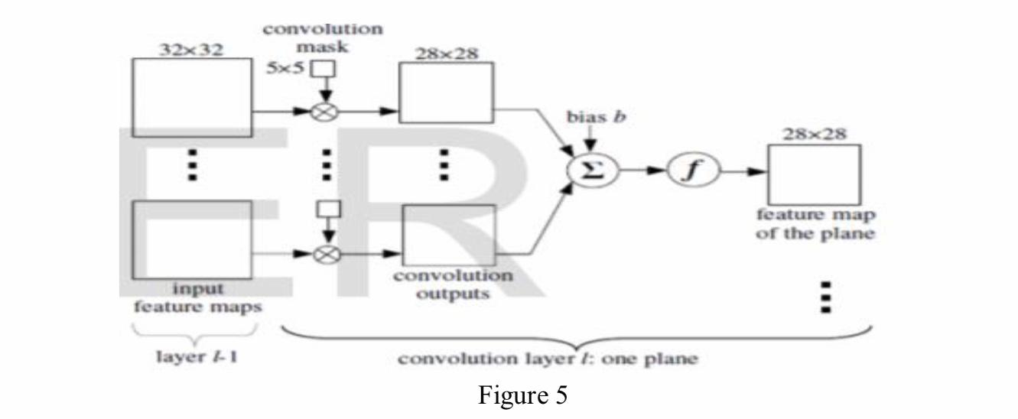

The subsampling layer comes after the convolutional layer. It has the same number of planes as the convolutional layer. The purpose of this layer is to reduce the size of the feature map. It divides the image into blocks of 2x2 and performs averaging. Sub sampling layer preserves the relative information between features and not the exact relation.

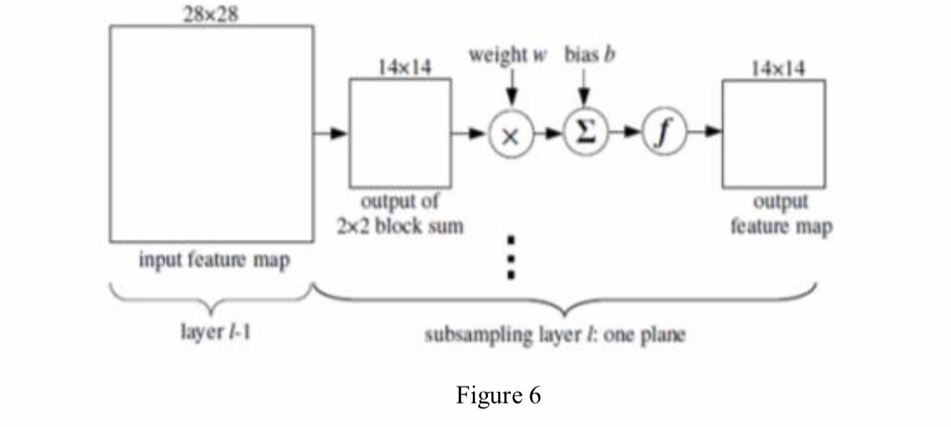

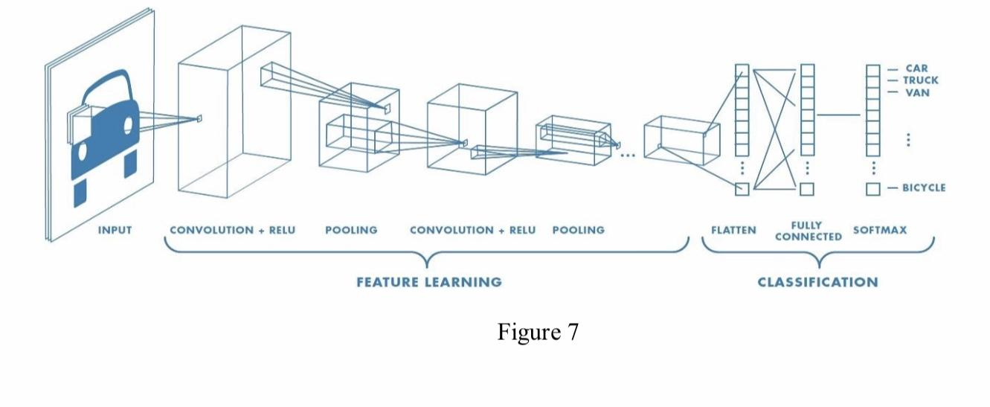

**9. Overview of Proposed Model**

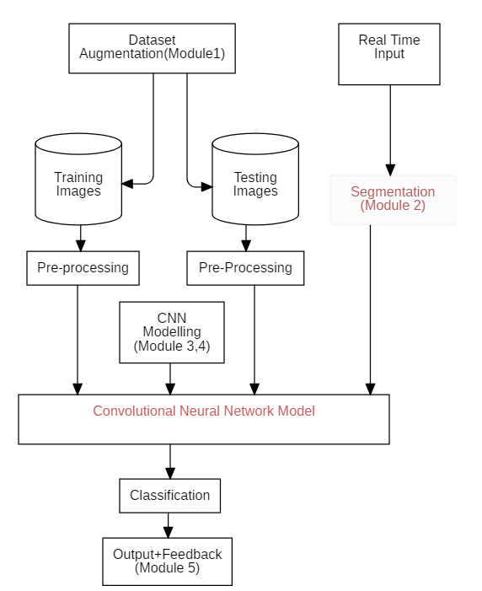

**Module 1: Data Augmentation**

Data augmentation is the process of increasing the amount and diversity of data. Data augmentation is an integral process in deep learning, as in deep learning we need large amounts of data and in some cases it is not feasible to collect thousands or millions of images, so data augmentation comes to the rescue.

For Handwritten Script Recognition System we use,

1. IAM Handwriting Database-

The IAM Handwriting Database contains forms of handwritten English text which can be used to train and test handwritten text recognizers and to perform writer identification and verification experiments.

The database was first published at the ICDAR 1999. Using this database an HMM based recognition system for handwritten sentences was developed and published at the ICPR 2000.

The database contains forms of unconstrained handwritten text, which were scanned at a resolution of 300dpi and saved as PNG images with 256 gray levels.

2. UCI Machine Learning Repository Davanagari Handwritten Character Dataset

This is an image database of Handwritten Devanagari characters. There are 46 classes of characters with 2000 examples each.

Image format : .png

Resolution : 32 by 32

Actual character is centered within 28 by 28 pixel, padding of 2 pixel is added on all four sides of actual character.

**Module 2: Segmentation**

A writing can be segmented based on line, word, and character. On line segmentation is detected by scanning the written image that has been inputted horizontally.

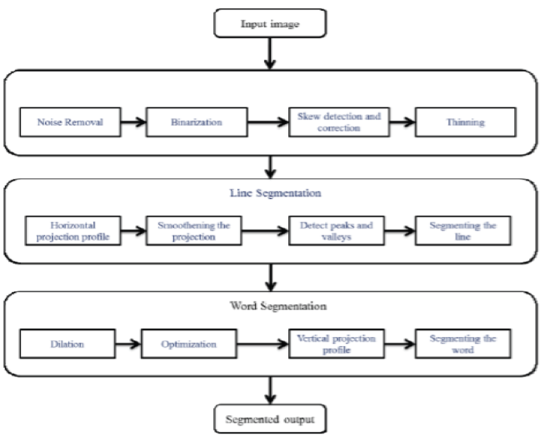

**Module 3 & 4: CNN modeling**

**The Module 3** involves conversions for handwritten script in English or Hindi to digital text format in the same language.

**The Module 4** involves conversions of handwritten script written in one language (English/Hindi) to a digital text format in another language.

CNNs are used in variety of areas, including image and pattern recognition, speech recognition, natural language processing, and video analysis. There are a number of reasons that convolutional neural networks are becoming important. In traditional models for pattern recognition, feature extractors are hand designed. In CNNs, the weights of the convolutional layer being used for feature extraction as well as the fully connected layer being used for classification are determined during the training process. The improved network structures of CNNs lead to savings in memory requirements and computation complexity requirements and, at the same time, give better performance.

**Module 5: Output and Feedback**

The Module 5 deals with the output which is typically a digital text format in English or Hindi which is generated by the model with handwritten script as input. As mentioned the product is a Web Application, the user is also given a chance to provide feedback of the application which helps us to improve the application and its accuracy.

**10. Implementation**

1. HSR Homepage

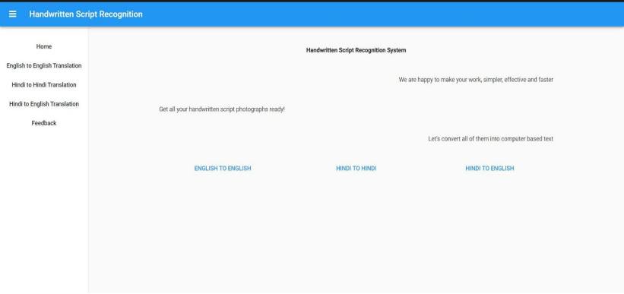

1. HSR English to English

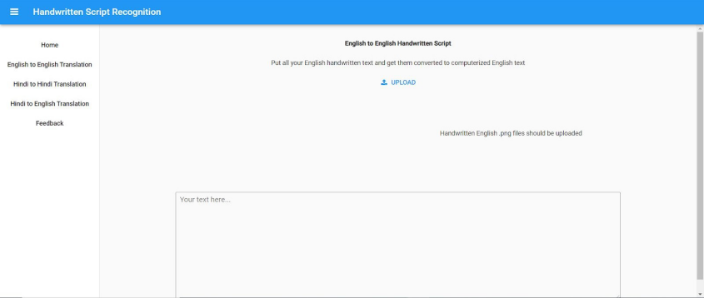

Working Model English to English

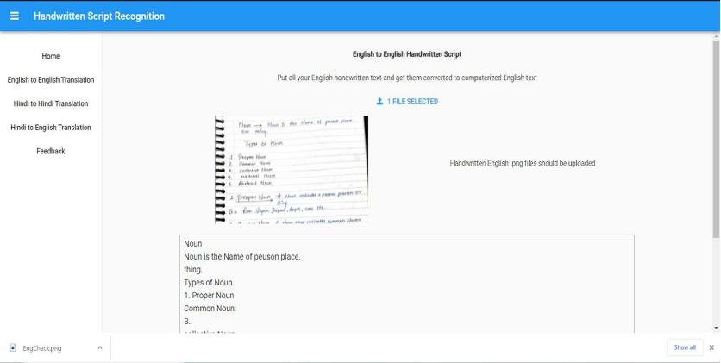

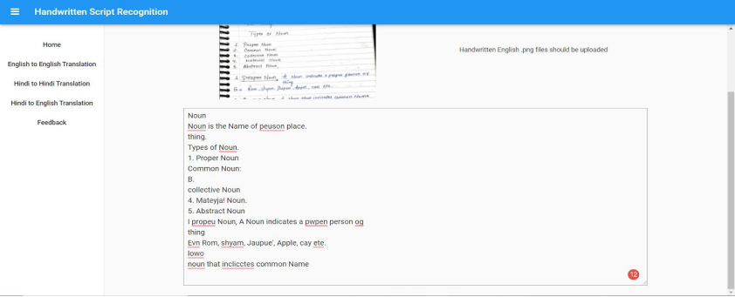

1. HSR Hindi to Hindi

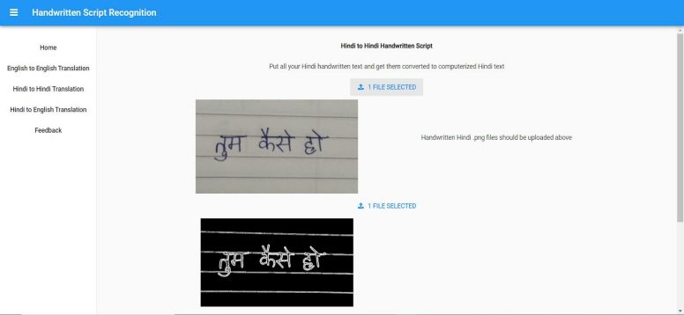

Working Model Hindi to Hindi

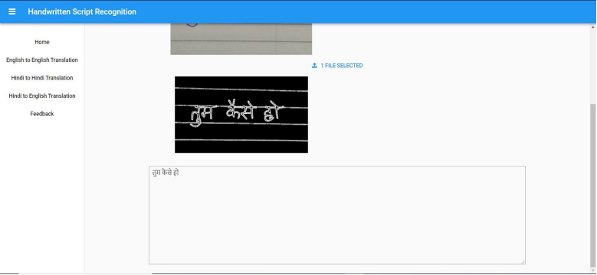

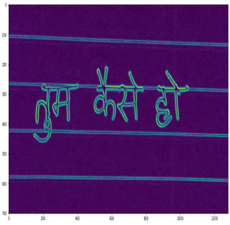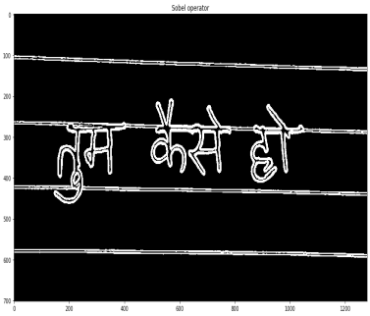

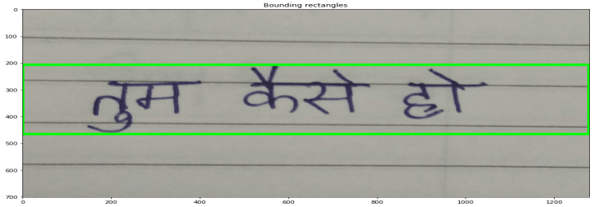

1. HSR Feedback

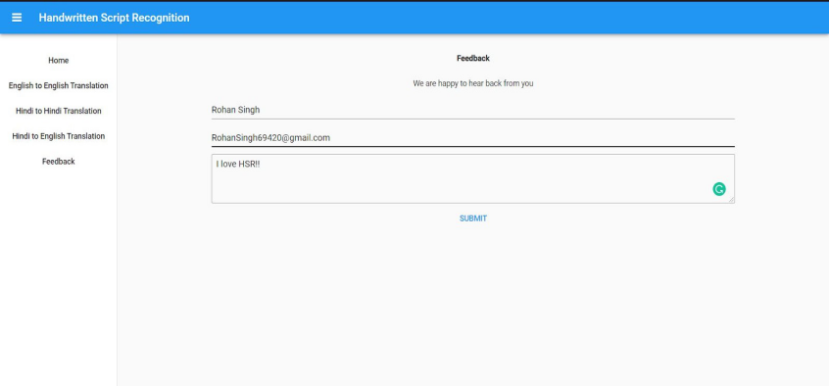

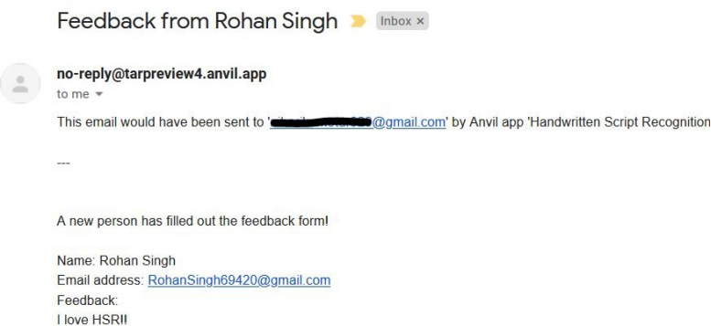

1. HSR Database Source

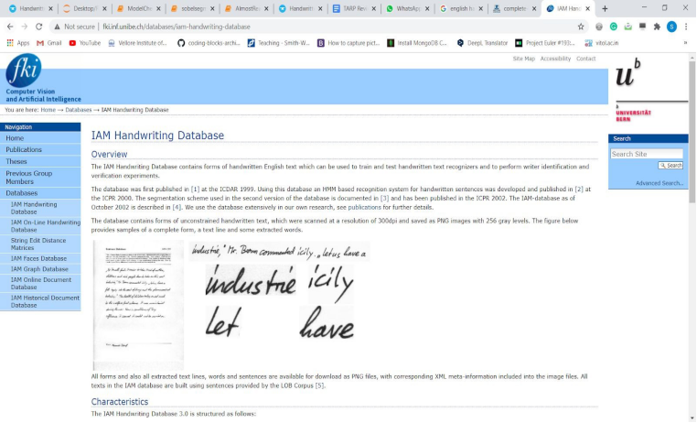

**11. References**

**[1]** Handwritten Bangla Character Recognition Using the State-of-the-Art Deep Convolutional Neural Networks by Md Zahangir Alom , Paheding Sidike ,Mahmudul Hasan,Tarek M. Taha,and Vijayan K. Asari

**[2]** Handwriting Word Recognition Based on Neural Networks from Dr. Alia Karim Abdul Hassan, Mustafa S. Kadhm dated October, 2015

**[3]**  Ote-Ocr Based Text Recognition and Extraction from Video Frames by Shashank Shetty and Arun S Devadiga

**[4]** Machine translation using natural language processing from Middi Venkata Sai Rishita, Tanvir Ahmed Harris dated January, 2019

**[5]** Text Recognition Using Poisson Filtering and Edge Enhanced Maximally Stable Extremal Regions by Jiji Mol , Anisha Mohammed and Mahesh B S

**[6]** Optical character recognition technique Algorithms from N. Venkata Rao, Dr. A.S.C.S.Sastry, A.S.N.Chakravarthy, Kalyanchkravarthi P dated 20th January 2016